**Software Development Life Cycle**

A software development process, also known as a software development life cycle (SDLC), is a structure imposed on the [development of a software product](http://en.wikipedia.org/wiki/Software_development). There are several [models](http://en.wikipedia.org/wiki/Software_development_process#Software_development_models) for such structures, each describing approaches to a variety of [tasks or activities](http://en.wikipedia.org/wiki/Phases_of_the_software_development_cycle) that take place during the development process.

**Waterfall Model**

This project follows 'The Waterfall Model' for the SDLC. In this approach, the whole process of software development is divided into separate phases. These phases are:

1. Requirement specifications phase
2. Software design
3. Implementation
4. Testing and maintenance

All these phases are cascaded to each other so that the next phase is started as and when a defined set of goals are achieved for first phase and it is signed off. Hence the peculiar name. All the methods and processes undertaken in the model are more visible.

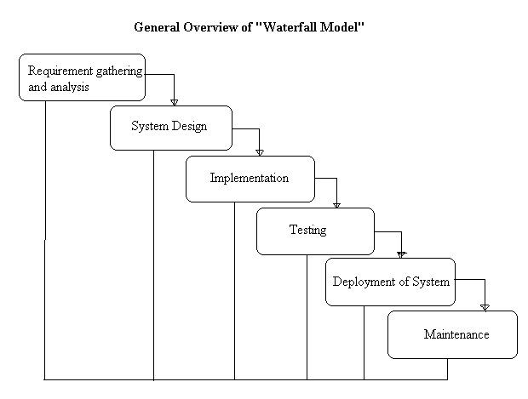

Reasons To follow this Approach:

The project requirements are very well known, clear and arefixed. There are no ambiguous requirements. Similarly, the technology is going to be used is also known. As every phase is fixed, there is no need of revisiting.